Software Requirements Specification
for
Go-safe
Version 1.0
Prepared by Guda Jagan Mohan Reddy
NU
17/9/2016
Table of Contents
Table of Contents
Revision History
1. Introduction
1.1 Purpose
1.2 Document Conventions
1.3 Intended Audience and Reading Suggestions
1.4 Product Scope
1.5 References
2. Overall Description
2.1 Product Perspective
2.2 Product Functions
2.3 User Classes and Characteristics
2.4 Operating Environment
2.5 Design and Implementation Constraints
2.6 User Documentation
2.7 Assumptions and Dependencies
3. External Interface Requirements
3.1 User Interfaces
3.2 Hardware Interfaces
3.3 Software Interfaces
3.4 Communications Interfaces
4. System Features
4.1 Administrator
4.2 Mailing
4.3 Client
5. Other Nonfunctional Requirements
5.1 Performance Requirements
5.2 Safety Requirements
5.3 Security Requirements
5.4 Software Quality Attributes
5.5 Business Rules
6. Other Requirements
Appendix A: Glossary
Appendix B: Analysis Models
Appendix C: To Be Determined List

Revision History
Name | Date | Reason For Changes | Version
Jagan | 17/9/16 | Creation of SRS | 1.0

Introduction

Purpose
Defining and describing the functions and specifications of the GoSafe system is the primary goal of this Software Requirement Specification (SRS) Document. The product is cab booking and sharing in regional areas. Initial version allows connection between cab services and customers, also notifying them about the presence of sharable cabs. SRS describes the single subsystem i.e from beginning, all the services provided.

Document Conventions
Bold formatting is used to represent important or main topics.
Underlining to represent important headings.
Written in formal documentation format.

Intended Audience and Reading Suggestions
SRS provides information about requirements for the product which can be read by all. As it is open source project all are enabled to read our SRS which provides us huge treasure of information to develop it’s versions with new features. Project manager, service providers, users, developers are allowed to go through SRS. One type of feedback. Git Hub will also enable same issues. Readers are suggested to read continuously or based on their interests.

Product Scope
This type of products are already running on roads like uber and ola cabs. But the application we are creating doesn’t take any reference from them like coding part, user interface. Only our idea is to create a platform for cab services and users which is highly required at NU.

References
http://www.guru99.com/traceability-matrix.html

http://argouml.en.softonic.com

http://www.utdallas.edu/~chung/RE/Presentations07S/Team_1_Doc/Documents/SRS4.0.doc

http://www.academia.edu/3563689

Overall Description

Product Perspective
This product is a follow on member of many other products. Mainly providing services in the areas where they are not working and not implemented, created with our own knowledge and requirements. Initial release is only about informing both users and providers the booked cabs and sharing cabs. Available cars to the users which will be updated by some worker.
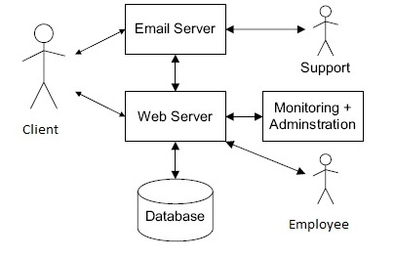
Use case diagram:

Product Functions

- An account will be created for the first log in.
- So that we can show them their past booking history.
- It enables users to have a look at all available cars ready for travelling.
- They can book cabs personally or on share basis which is optional feature on their interests.
- They will also be provided buffer time which allows them to cancel the booked cab.
- There will be auto conformation based on email and messages which will be sent to both cab driver and users at the same time.
- They can book a cab within the radius of 200 km.
- Getting feedback for future development of this product.

User Classes and Characteristics
Irrespective of age or class all the students, faculty, working men can use our product. We aspect our users will be 1k users per year. All users of this product will be treated equally with best satisfaction of having cabs since they have to use it again and again.

Operating Environment
Our initial release will be of web application which is compatible in all operating systems i.e in all windows, linux and in most of the web browsers like fire fox, chrome and opera in many. Users can also use this product in their mobile browsers which will be more convenient to all. While creation we are using sublime text editor for coding, languages we use are HTML & CSS, PHP and Java Script. For database issues WAMP server for trail run, 000webhosting.com provides free hosting with limited data.

Design and Implementation Constraints
We have mainly the following constraints
1. Updating the status of vehicles from time to time.
2. Human resource to be there always.
3. Availability of net.

User Documentation
Time to time there will be a person for online help and he will be the same person updating the availability of cabs which are operative. We will provide a small video describing how to book and check their history on the web page.

Assumptions and Dependencies
Net service is assumed to be accessible at the service provider offices. And a person to be updating the list and helping online. Instead there is no need of a particular person updating because as soon as the cab is booked it will not be in the list of available cabs. The working of this web app depends on the maintenance of server

External Interface Requirements

User Interfaces
- The user interface is getting done by HTML & CSS, Java script languages.
- We are not making high end interface right now because it is time consuming.
- We have properties like popups and notifications for the clients understanding for any wrong inputs given by them.

Hardware Interfaces
- In this digital age we are not going to have our own hardware for some works like servers, copy of data.
- We just use the services provided by already running and service providers. Clients will not have a look at any of the product hardware.

Software Interfaces
- Most of all web browsers allows to have interface of our product. To which HTML&CSS, Java script holds the base for software interface.
- The client network should support one of the network protocols TCP/IP
- Database management system is taken care of by SQL.
- For Scripting, code editing we are using sublime text editor.

Communications Interfaces
- The communication server protocol maintained is TCP/IP. Which will have reduced layers from OSI model which helps us in fast transmission (communication).
- HTTP protocol will be used which is basic protection of web app for not losing data and not letting into bad hands.

System Features

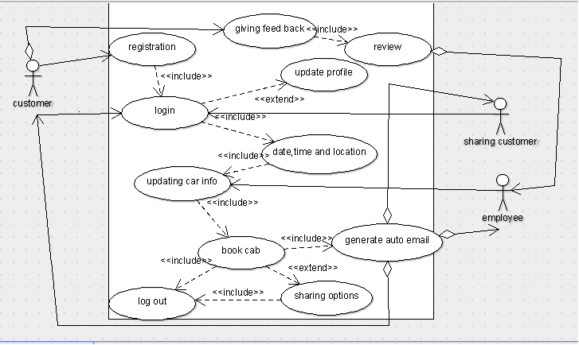

Requirement id Function

R1 registration
R2 log in
R3 update profile
R4 date, time & location
R5 car info
R6 book cab
R7 share option
R8 auto email generated
R9 give feed back
R10 review

4.1 Administrator:
4.1.1 Description and Priority
Administrator is the owner of the product and should have good catch of all services provided. But will not be able to edit the main data of the users or developers. He can only supervise the actions that will be happening on the web app.
    - Stimulus/Response Sequences
The administrator will have also be provided secure log in as he should be the only one to be inspecting all the undergoing work. That means he will have separate dashboard different from others.
    - Functional Requirements
His dashboard consists of links to the further pages for inspection of data. He can also send mails directly from web app as it will have extensions already available on web browser stores. Key password will only be available to the administrator which can be locked for each and every connector to the web app and so does too in emergency situations. He has the authority to cut off clients for particular issues.

Requirements for Administrator are:
REQ-1: Perform weekly roster of Employees
REQ-2: Print reports annually, weekly, and daily
REQ-3: Check feedbacks
REQ-4: Send newsletters
REQ-5: Manage user portfolio
REQ-6: Changing the super password.
4.2 Mailing
4.2.1 Description and Priority
Mailing system is the one of the most important requirements for the software. An automated mail will be sent to the client as well as to the administrator with the information of the booking, feedback respectively.
4.2.2 Stimulus/Response Sequences
∙Mail will be sent to the user after successful booking of a cab
∙Mail will be sent to customer1 if the other customers wants to share the cab with him.
∙A conformation mail will be sent to the both the customers on booking the shared the cab.
∙A mail will be sent to the user if he forgot the password or username.
4.2.3 Functional Requirements
Automatic mail generator is developed using PHP .An automatic mailing system will generate all the necessary mails that are required with the use of PHP on the click of a button specified by developers.
REQ-1: Temporary password will be mailed to the user in case the user forgets the password.
REQ-2: Newsletters should go the clients email addresses.
REQ-3: The client should get notification email of the booking while confirmed.
REQ-4: Admin will get a mail if any customer gives the feedback.
REQ-5: Notification mail will be sent to the customer after booked by any other customer.
4.3 Client
4.3.1 Description and Priority
Here how the customer will login and log out of our system. What are the features the clients can get to experience from our system!! .
4.3.2 Stimulus/Response Sequences
· Customer has to register on the first log in to access the features of the website.
· After that the user has to login into our website with the particular username and password.
· Then the customer has to give the date, time, and location for the cab to arrive.
· Then select the cab from the available list of cabs from our website.
· The client can cancel the cab in a span of hour.
· The client can even go for sharing the cab.
· After booking the email will be sent to his/her registered mail.
· Then the client can logout.
4.3.3 Functional Requirements
The customer can has first to register then only the customer can login into our website. There will be authentication for the client, whether the user is giving a correct details or not. The username and password will be sent to the customer’s email. When the login typed by the wrong username or password then there will be an error. After the customer login’s into the website then the customer can give the information of date and time and location from where the customer will travel. After that the customer can book the cab he wanted according to his specifications. The customer can cancel the booked cab only in a span of hour as the cab driver will enrooted to his location. After that MAILING will be done. Then the customer can logout from our website.
REQ-1: Register and Login in our website
REQ-2: Authentication of the login
REQ-3: Logout from the website
REQ-4: Change Password
REQ-5: Resetting the password
REQ-6: Date, time and location
REQ-7: Selecting cab
REQ-8: Cab booking
REQ-9: Cab canceling

Other Nonfunctional Requirements

Performance Requirements
When we perform with local host it will only be trail base. We can’t even start and maintain our product on WAMP servers. When we are able to get raise in money we can afford paid servers. Till that time we will run it only on free hosting providers.

Safety Requirements
- For safe and secure logins additional information will be gathered from the user and making their work hassle free.
- For each log in the user will be provided session id which will only be active for a stipulated time. Prevents unnecessary resting time on our web app.

Security Requirements
- Server protocols take some care of encryption and decryption of data while receiving and sending.
- Additionally HTTPS protocol avoid some of hackers to intrude and data will be safe.
- We will provide one time passwords, log in with Google and Facebook for easier and safe logins in further versions.
- We will store each activity of all clients, updaters so that we can cross check for any disturbances as activity log in our database.
- When there will be high traffic we can’t maintain it. For any bot entries we will secure our product by captcha.

Software Quality Attributes
Dashboards will be different for users’ clients, service providers, developers and authorities.
Where the developers will have complete access to each pinpoint area and part. While service providers can only edit the available cabs, and clients can book and cancel their cabs while they can only see their past history without a chance for editing. Hence our product has high flexibility to certain extent based on their position. In the developing condition robustness will be low compared to our perceptions and aspiration.

Business Rules
Our product came out of the troubles faced by local clients in getting cabs. Hence it focuses on serving clients at peaks. We will also provide a online helper 24/7.

Other Requirements
Some non-software based requirements needs to be considered:-
- Maintaining the service log of each vehicle will be become an essential requirement in future.
- Maintaining the car wise Accident details.
- Maintaining the breakdowns and services of vehicles.
- Also, maintaining the details of company, vehicles owned, records of employees, financial records are needed.

Appendix A: Glossary
SRS: software requirement specifications
HTML: Hyper Text Markup Language
SQL: Structured Query Language
CSS: Cascading Style Sheets

Appendix B: Analysis Models

Appendix C: To Be Determined List
• Other sites can redirect to our page for transport like for going to railway station, airport, or even make a plan for tour.
• Should or should not make the transaction be done through a gateway or the client will directly pay to the cab driver.

